First Run:
PS C:\Users\micha\DLMDSP WP01\Factorized Code> python -m dlmdsp.dlmdsp_cli
>>
CWD: C:\Users\micha\DLMDSP WP01\Factorized Code
argv[0] dir: C:\Users\micha\DLMDSP WP01\Factorized Code\dlmdsp
[ERROR] Compiling criterion not met: No valid assignment for x=-8.7, y=-16.843908; deviations=[('2', 0.8875770000000003), ('3', 8.143908), ('4', 17.092072849999997), ('1', 33.869585)], tolerances={'1': 0.7014046721030611, '2': 0.7038583326337785, '3': 0.7056020579561832, '4': 0.7067413342598947}

The code block that lead to the code stalling was placed into try/except block
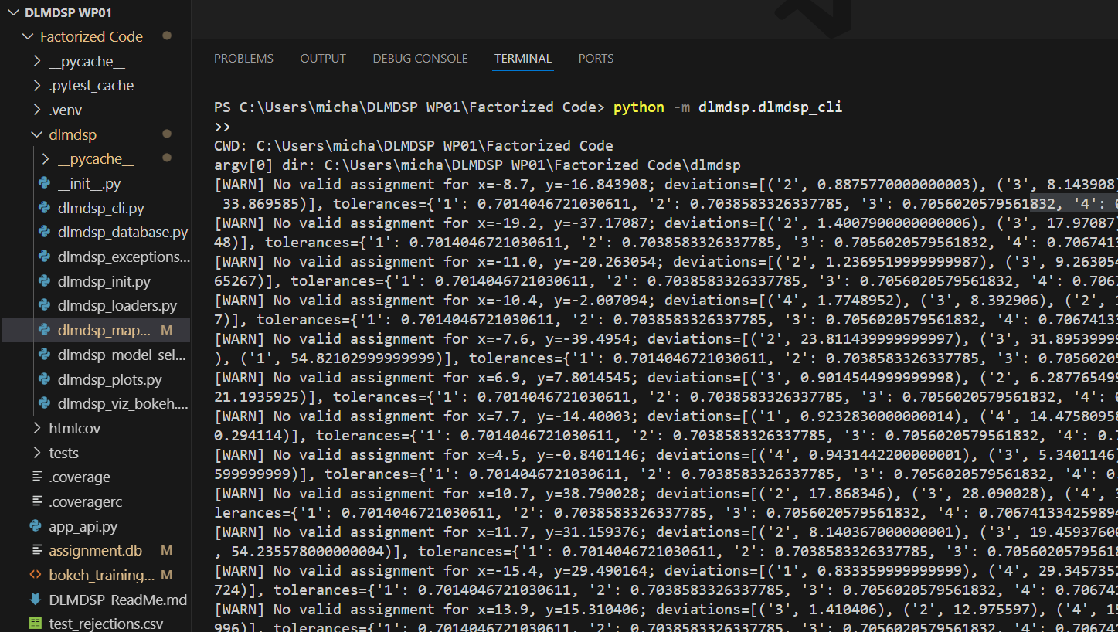
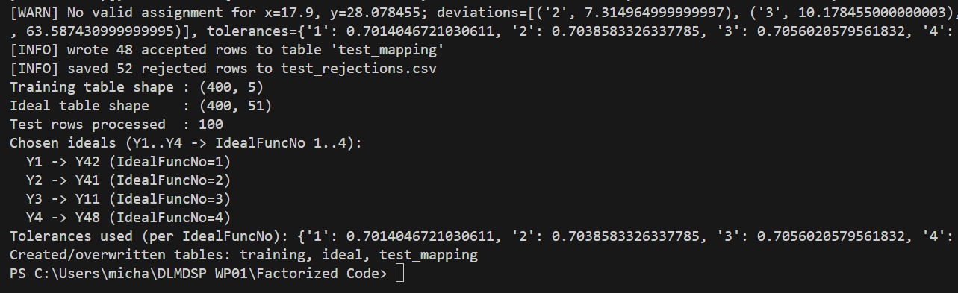

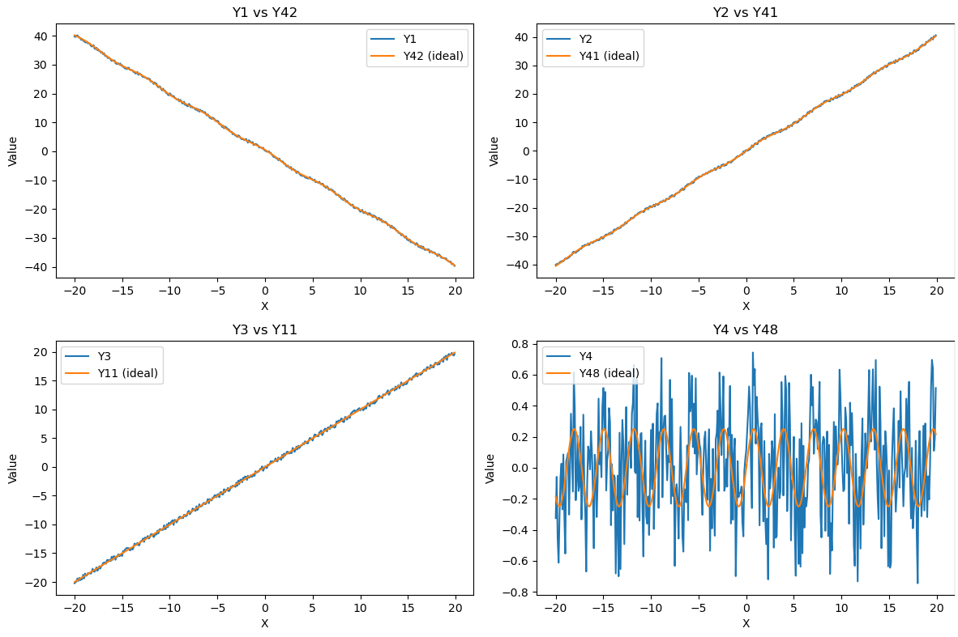

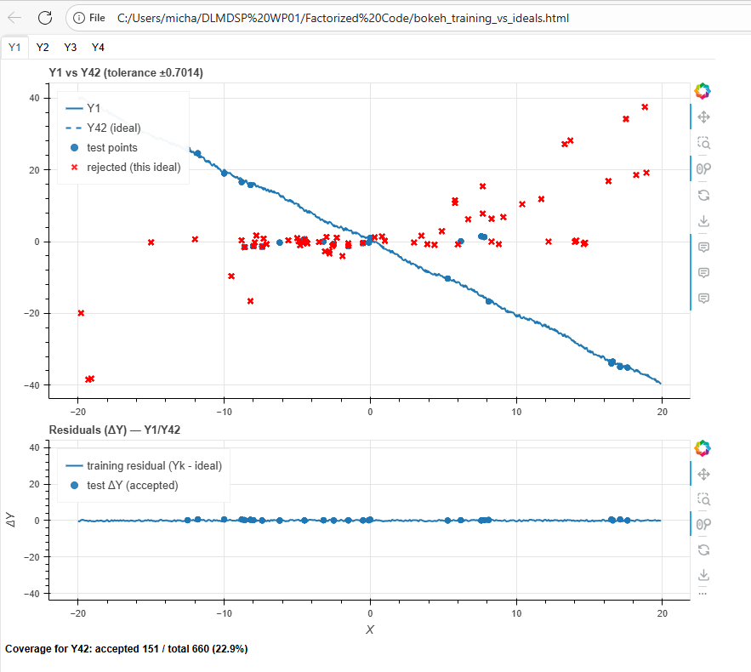

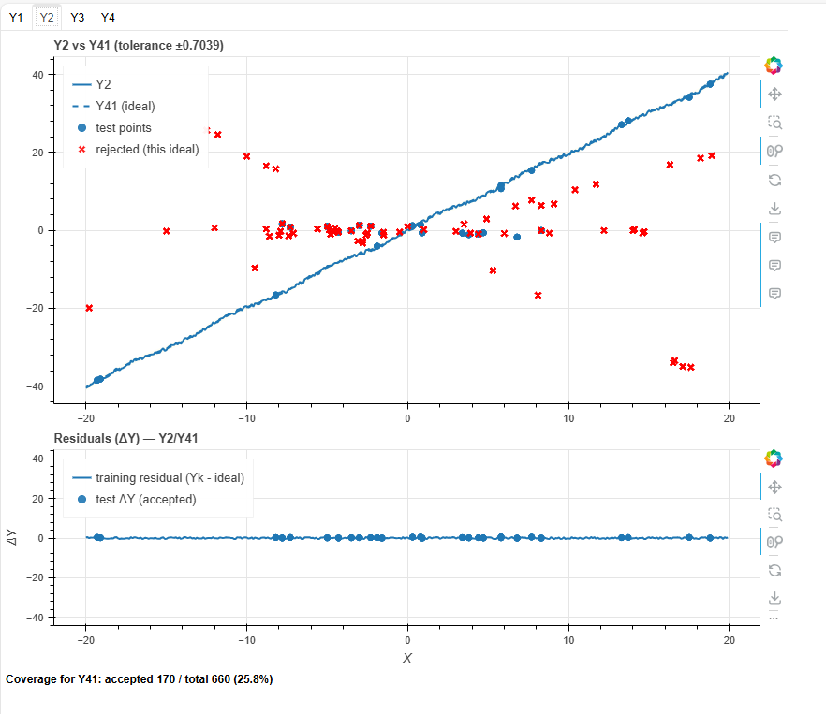

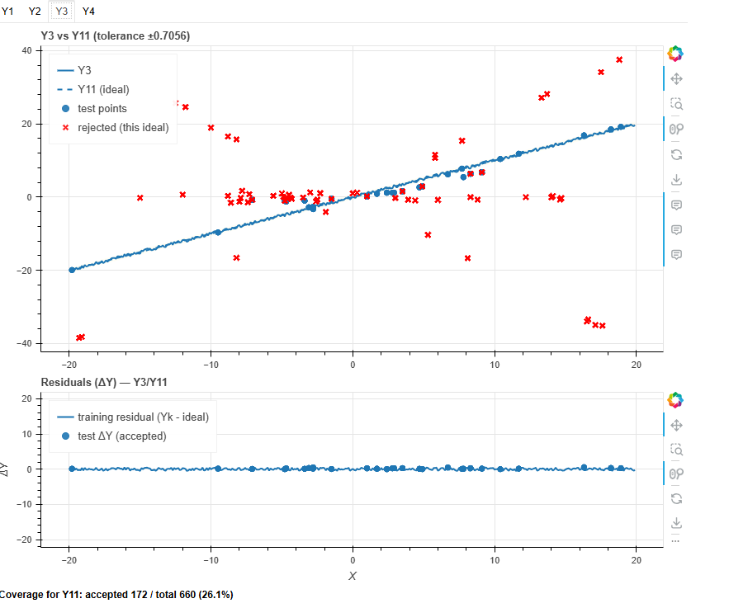

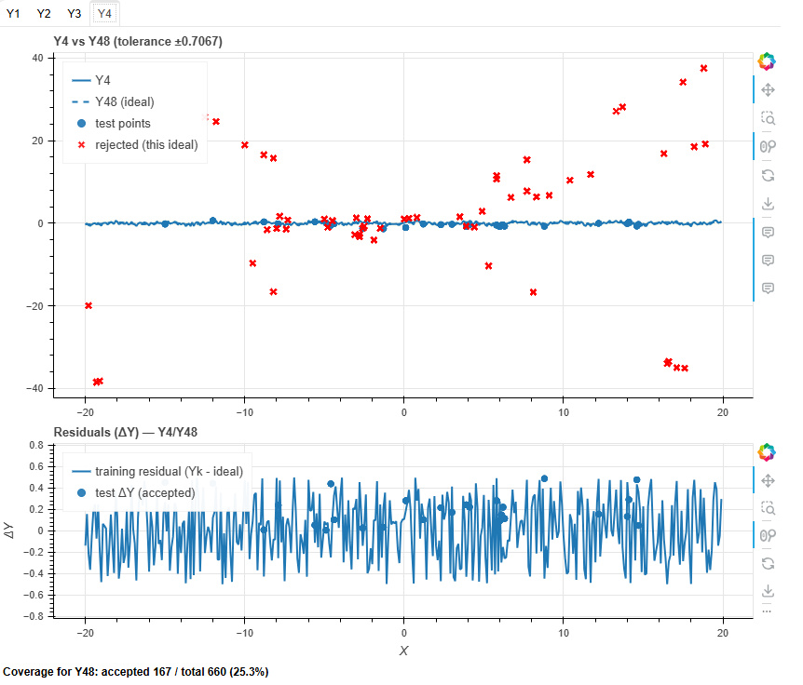

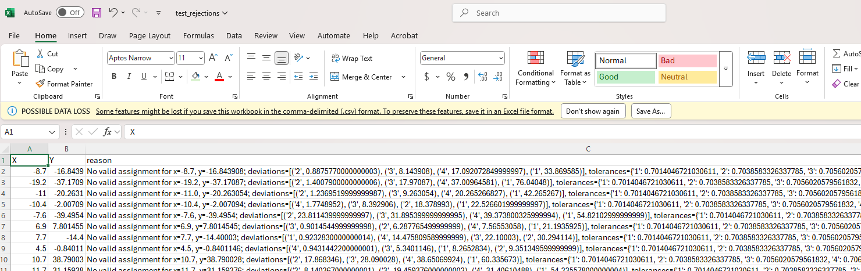
Row summary
- X, Y: −8.7, −16.843908
- Best matching ideal: #2 with deviation 0.887577
- Tolerance for ideal #2: 0.703858 (rule: |ΔY| ≤ tolerance)
- Other deviations: #3 = 8.143908, #4 = 17.092073, #1 = 33.869585 (all ≫ ~0.70 tolerances)
- Outcome: Rejected — even the smallest deviation (0.887577) exceeds its tolerance, so the point is unassigned (“No valid assignment”).

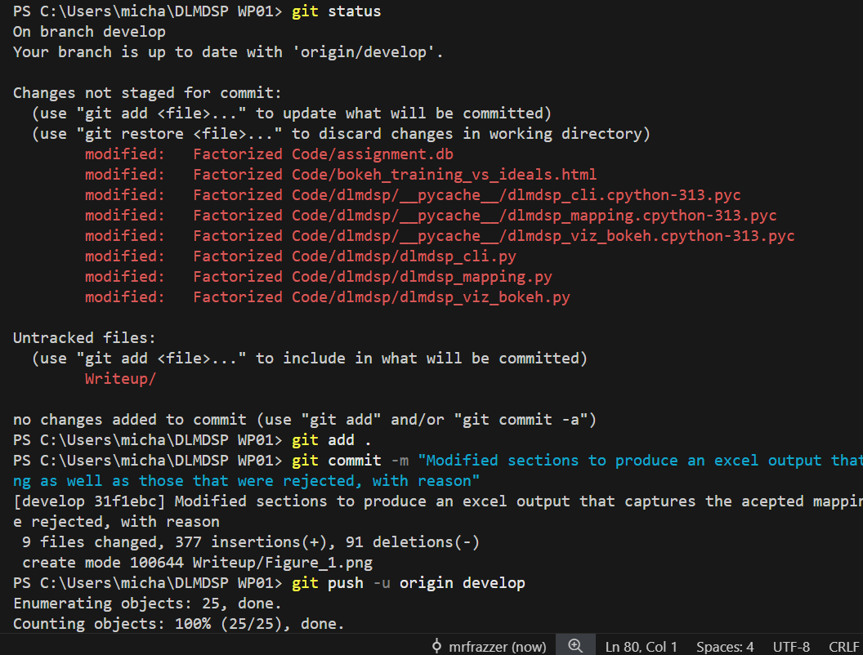

g

